**EAGLE GROVE UNITED METHODIST CHURCH**

*Love God, Love Others, Change the World*

*“Making disciples of Jesus Christ for the Transformation of the World”*

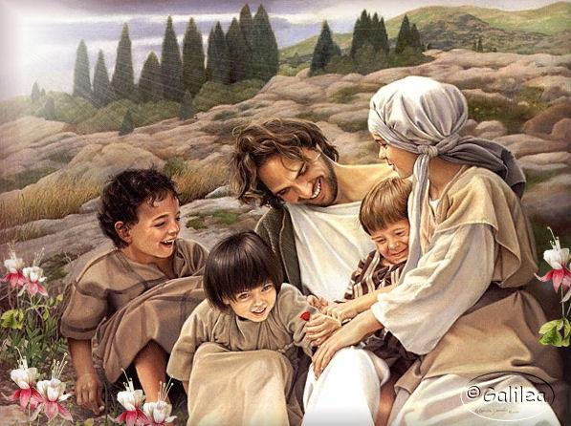

***CELEBRATE SCHOOL DAYS & LOVE***

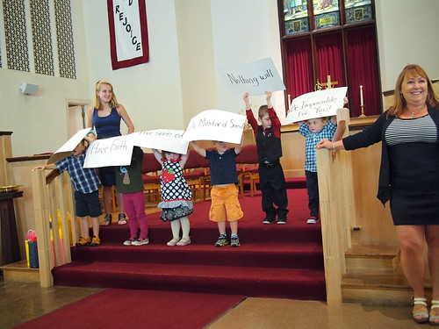

421 West Broadway Street

P.O. Box 101

Eagle Grove, IA 50533

Church Office: (515)-448-4701 [egumc@goldfieldaccess.net](mailto:egumc@goldfieldaccess.net)

Church Office Hours: Tues-Thurs 9:00 to 11:00 A.M. Sunday Worship 9:30 A.M.

SEPTEMBER NEWSLETTER 2025

**Jerry’s Words**

I have asked to contribute a brief item for our study and consideration for this month. I will start by suggesting that we think on a portion of scripture found in John 1:37-39

“The two disciples heard him say this and followed Jesus. When Jesus turned and noticed them following him, he asked them, ‘What are you looking for?’ They said to him ‘Rabbi’ (which means “teacher”), ‘Where are you staying?’ ‘Come, and see,’ he replied. So, they went and saw where he was staying, and they stayed with him that day…”

What would you say or do if someone came to you and asked you to help them learn how to do some task you perform in your job, or in some hobby, something that you do well? Would you write everything you know and give it to them? Would you tell them to go find a professional instructor and have them teach the skill?

More than likely. We would all invite them to come with us so we could show them the basics, and they could see for themselves the step-by-step process and start learning. Sharing our faith may be much the same. Perhaps we feel that we need to be more qualified to lead someone to Christ because we don’t know everything about our faith. We could maybe write down a few Bible verses and wish them luck.

Within our congregation when we have been faced with long periods of time without a pastor, perhaps it is important that each of us hear the examples set in the book of John as stated in John 1:37-39 as well as in John 1:46-49. In those two examples we see Jesus and then Philip inviting people to “come and see” in order to learn more about God.

Should we also not invite people to return to active participation within the congregation? Remember, the words of the old Gospel hymn which states that “we are the church together”.

*Thank you, Jerry, for wise words.*

Leading by Example

We are the church

ARE YOU REMEMBERING TO READ PRAYERS FROM THE HYMNAL?

*FOR RENEWAL OF THE CHURCH*

*Renew your church, Lord,*

*Your people in this land.*

*Save us from cheap words*

*And self-deception in your service.*

*In the power of your Spirit*

*Transform us,*

*And shape us*

*by your cross.* ***Amen****.*



**LOOK FOR INFORMATION, EVENTS AND DATES**

**HAPPY BIRTHDAY**

**SEPTEMBER**

Sept. 2—Daphne Willwerth

3—Sheryl Steans

9—Dave Poncin

10-Brecklynn Meyer

11-Gavin Groth

12-Tracy Crail

16-Josh Amonson

17-Jackie Habben

21-Azlyn Amonson

23-David Morgan

29-Mollie Davidson

29-Alex Helmick

**INGATHERING KIT FOCUS**

**Personal Hygiene Kit**

1 wash cloth-no kitchen dishcloth

1 hand towel-no kitchen towels

1 adult toothbrush-no multiple packs

1 bar soap -3-4 oz

1 shampoo- 12-19 oz

1 deodorant- 2-3 oz (stick, roll on, pump)

1 lotion 8-10 oz

1 one-gallon resealable plastic bag

Place all items in the plastic bag and add $2 Help those who are in need.

*\*What did the buffalo say when his son left?*

*Bison*

*\*What do you call a cheese that isn’t your cheese?*

*Nacho cheese*

**LOOK FOR MORE INFORMATION, EVENTS AND DATES**

**Greeters**

**Liturgists-**

7th-Deb Thielen

14th -Dave Poncin

21st-Larry Hill

28th -Daphne

**Dial-A-Devotions**

2nd-Paul Wilde

9th -Sharon Seibert

16TH Joel Stein

23rd -Kurt Knudsen

30th -Sharon Seibert

**Pulpit** – 7th Jerry Becker

14th Ann Trimble Ray

21st Lorene Dykstra

28th Ann Trimble Ray

**Coffee** - 7th Helmicks

14th Blanche Bosteder

21st Pat Manues

28th Barb Johnston

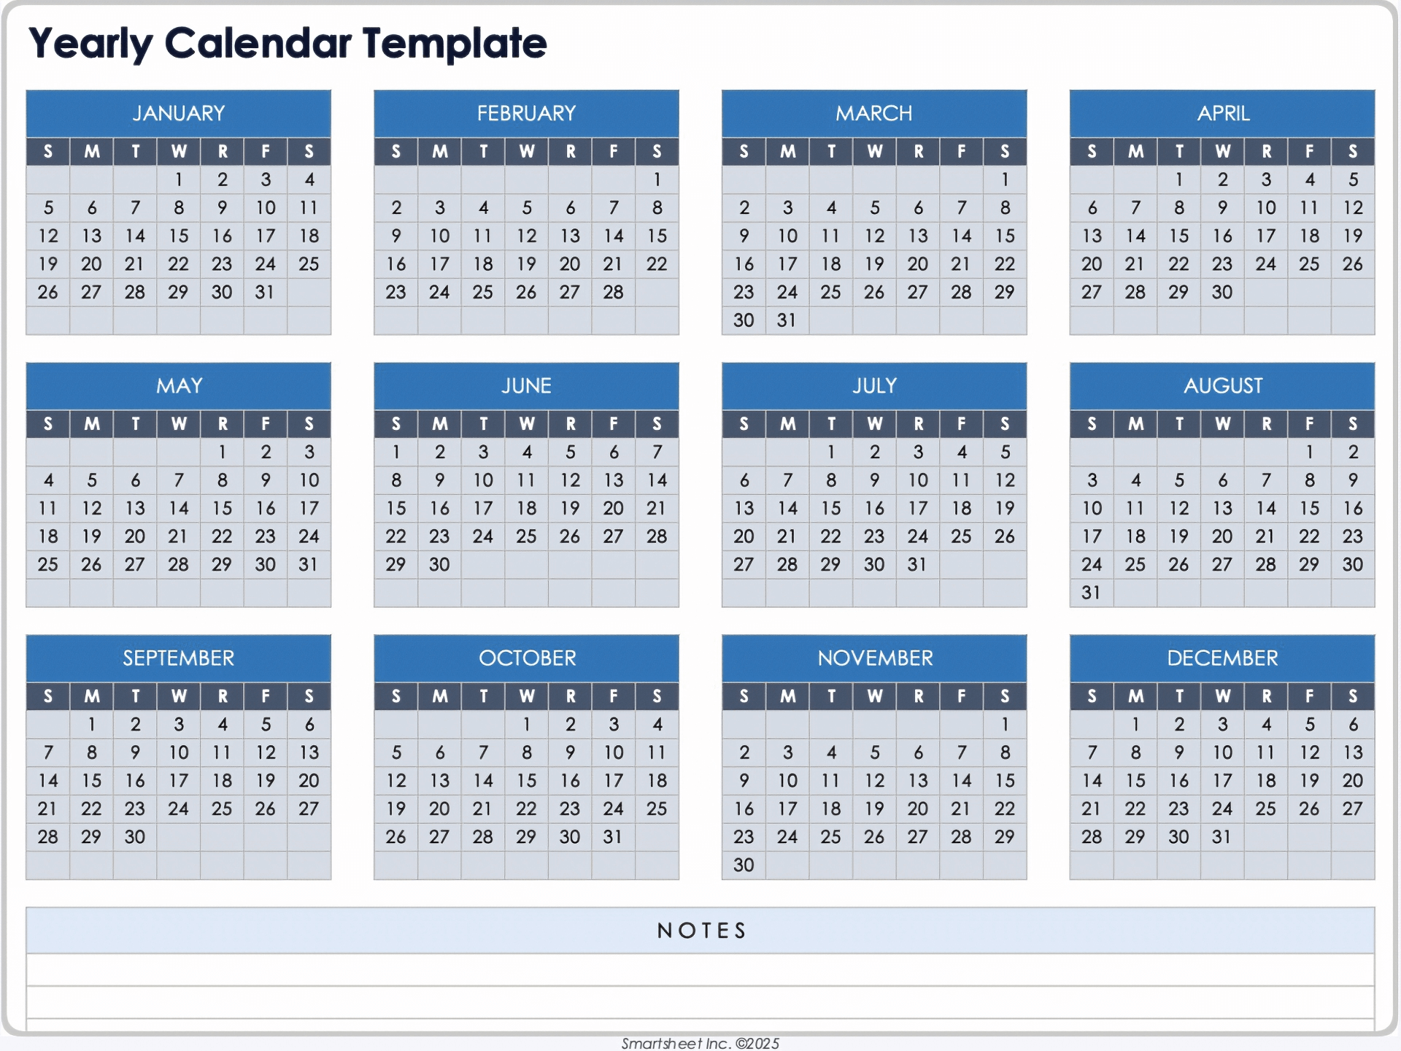

**Month of September**

Sept. 1- Labor Day

4- Women of Faith 9:30 A.M. Hostess- Barb Johnston, Devotion- Melody Amonson

5- Fifth Quarter 9-11 P.M. in Fellowship Hall

7-10:30 A.M. Administrative mtg. after service

10-Worship mtg. 9:30 A.M.

11-EGAMA mtg. 10:00 A.M.

12- Fifth Quarter 9-11 P.M. in Fellowship Hall

14-Kids Sunday School during Church Service

14-Communion Sunday

17-After School Kids’ Club

17- Faith Formation 4:30 P.M.

17- Youth Group 5:30 P.M.

20-Men’s Bible Study 7:00 A.M. Family Table

24- After School Kids’ Club

26- Fifth Quarter 9-11 P.M. in Education Building

28- Administrative mtg. after Church Service

Come into the office to check out discs and players. You can use a CD player at home. Anyone not using CD player any more may donate to someone who doesn’t have one.

DID YOU KNOW THIS?

Celebrate the Successful New Event!

**

**Our very own Youth Leaders saw an activity they thought needed to be done for the local youth. Reaching out to the school and others, people volunteered to help, participate, and encourage kids to come for this back-to-school activity for High School kids. Snacks and bracelets were given to remind these young people how important Jesus is to their lives. Congratulations to one and all who made this a night to reach out and to serve.**

**Youth Group Wednesday Meals**

Youth Group of 2025, grades 8th- 12th , is looking for help to provide meals for class nights.

Classes are held on Wednesdays from 5:30-7:00 P.M.

If you can help, we ask that you bring the meal prepared and have it set up ready to be served by 5:30.

We invite you to stay, to eat and visit with the class and kindly ask that you clean up and take leftovers home. We would guess this mealtime to be about 20-25 minutes. Plan on feeding approximately 10-12 people.

If you would like to contribute but are unable to be there to serve and clean up the meal, please reach out to us, and we would be glad to help.

To sign up please contact:

**Yalonda Amonson (319) 610-2593** [**yalondaamonson@gmail.com**](mailto:yalondaamonson@gmail.com)

There is a sign-up sheet on the table at the back of the sanctuary.

*Dinner inspiration ideas the kids helped to brainstorm: chicken Alfredo, slider sandwiches, tacos, chili, baked potato bar, red velvet cake, breakfast for dinner spaghetti, roast, broccoli cheese soup.*

**Yummy, Yummy, Yummy in our tummies! Thank you for the good food!**



**KIDS CLUB WILL BE STARTING SEPTEMBER 17TH**

The kiddos are back at school and schedules are beginning.

That means Early Out Wednesdays. That means kiddos will be coming to the church in the afternoon. Nicole Nicolletti-Calvert is leading the classes and activities are in the Fellowship Hall in the basement of the church. Students will enter through the west door. Registration sheets need to be filled out for the safety of the children and church.

Calendar as of now: Sept. 17 & 24; Oct. 1, 15, 22, 29; Nov. 5, 12, 19; Dec. 3, 10, 17; 2026 Jan.7, 21, 28; Feb. 4, 11, 18, 25; March 4, 18, 25; April 1, 8, 15, 22, 29; May 6th is the end.

Helpers are needed to feed, to clean up and to aide in activities.

Contact Nicole to help 515-364-2143

