**July 20, 2025**

**PRELUDE/CANDLELIGHT**

**WELCOME & ANNOUNCEMENTS**

**\*HYMN:** Christ Beside Me TFWS2166

\***CALL TO WORSHIP**

Children of God, in Jesus, Love became flesh and moved into the neighborhood. **We gather to worship Christ, the image of the invisible.**

In Jesus, we meet the fullness of God with no barriers to access. **We gather to worship Christ, the image of the invisible.**

In Jesus, our separation from God, neighbor, self, and creation has been removed. We are free for divine and loving connection once again.  
**We gather to worship Christ, the image of the invisible.**

Children of God, come! Come, let us worship God, whose power makes Love visible to us so that we might reflect Love to the world.  
**Come, let us worship Christ, Love who came to dwell among us and within us!**

**\*OPENING PRAYER (Unison)**

**O Christ, your cross speaks both to us and to our world. In your dying for us, you accepted the pain and hurt of the whole of creation. The arms of your cross stretch out across the broken world in reconciliation. You have made peace with us. Help us to make peace with you by sharing in your redemptive work. May we recognize your spirit encouraging and challenging us to care for creation and for the poor who most feel the effects of its abuse. Set us free and make us whole. Amen.**

**\*HYMN:** My Life Is in You, Lord TFWS 2032

**PRAYERS** Joys & Concerns – Silent Prayer – Pastoral Prayer

**OLD TESTAMENT LESSON:** Amos 8:1-12

**EPISTLE LESSON:** Colossians 1:15-28

**\*GOSPEL LESSON:** Luke 10:38-42

**\*GLORIA PATRI:** UMH #70

**MORNING MESSAGE: Walk Worthy of God** – Ann Trimble-Ray

**AFFIRMATION OF FAITH:** Apostles’ Creed UMH #881

**PRAYER OF CONFESSION**

**Forgive us, O God, when we limit you – when we remake you in our image, when we claim our causes as your own, when we box you in, and explain you away. And in our attempts at understanding, whittle away all mystery. Forgive us for our human impulses, and change us: awaken us to your glory,  
confound us by your love, shower us with grace so that we will be made new, recreated in your image, grateful for all that we cannot know. In the name of Christ, who brought us closer to you, we pray. Amen.**

**WORDS OF ASSURANCE**

Friends, let us proclaim the Good News:  
**In Jesus Christ, we are forgiven!**Let us go out into the world as people made new by God.  
**Alleluia! Amen.**

**\*OFFERTORY & DOXOLOGY**

**\*PRAYER OF DEDICATION**

**Holy and Loving God, in Christ, you have made the invisible visible, bringing us home with love beyond measure. As we offer these gifts, may they reflect our gratitude for your presence in our lives. Use them to build your kingdom, to restore what is broken, and to remind the world of your grace. May our giving be an act of thanksgiving, a sign of the ordinary magic of your love at work among us. In all things, may we walk worthy of you. Amen.**

**\*THE LORD’S PRAYER**

**\*BENEDICTION**

Go now in the blessing of Christ, love-made-flesh. May God’s loving presence surround you on every side, guiding you and empowering you to share God’s loving presence with everyone you meet. Amen.

**\*HYMN:**  Take My Life and Let It Be UMH399

*Stand as you are able

**ANNOUNCEMENTS**

**ONLINE GIVING:** Go to <https://app.tithely.com>, Login, and setup

an account.

**DIAL-A-DEVOTION:** Paul Wilde

**JULY 27TH**

**GREETER:** Tracy Crail

**LITURGIST:** Barb Forbes

**PULPIT:** Lavonne Hoover

**COFFEE:** Barb Johnston

Lazy SundayZ at the rescue ranch

July 27th 4-7 P.M. PB & J sandwich bar

1078 230th St. Goldfield

Great family activity

EAGLE GROVE UNITED METHODIST CHURCH

9:30 A.M. Service July 20th, 2025

Ann Trimble Ray

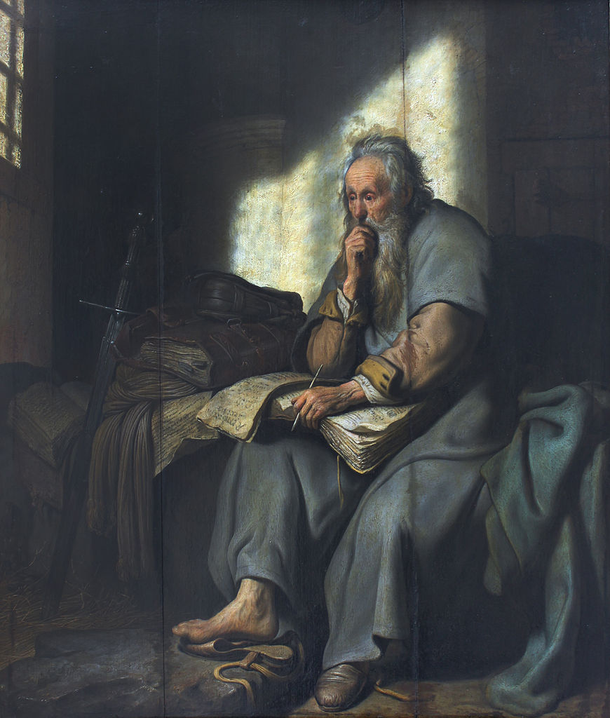

Colossians 1:25 *Paul’s Labor for the Church*

*I have become its servant by the commission God gave me to present to you the word of God in its fullness---*