SEPTEMBER NEWSLETTER 2025

EAGLE GROVE UNITED METHODIST CHURCH

*Love God, Love Others, Change the World*

*“Making disciples of Jesus Christ for the Transformation of the World”*

421 West Broadway Street

P.O. Box 101

Eagle Grove, IA 50533

Church Office: (515)-448-4701 egumc@goldfieldaccess.net

Church Office Hours: Tues-Thurs 9:00 to 11:00 A.M. Sunday Worship 9:30 A.M.

Dial A Devotion (515) 448-3355 A new devotion is recorded every Tuesday morning.

Dial A Devotion Greeters Liturgists Pulpit Supply

Aug. 5-Melody A. 3-Blanche B. 3-Kaye C. 3-Pastor Michel Lundula

12-Sharon S. 10-Sue W. 10-Pat M. 10-Lavonne Hoover

19-Sharon S. 17-Gloria B. 17-Jerrry B. 17-Gary Harris

26-Melody A. 24- 24-Susan S. 24-Ann Trimble Ray

31- 31-Kenlee Link 31- Ann Trimble Ray



**AUGUST**

Aug. 3 Pastor Michel Lundula will be preaching.

Aug. 5 Set up tables for luncheon

Aug. 6 Decorate tables 3-6 P.M. in Fellowship Hall

**AUG. 7 Women of Faith Salad Luncheon 11-1**

Aug. 16 Men’s Bible Study 7:00 A.M. at Family Table

Aug. 17 **Blessing backpacks for school**

Aug. 20 Faith Formation mtg. 4:30 P.M.

Aug. 21 Women of Faith serve Rotary 2:30 P.M. Peg Hill

Aug. 25 **First Day of School**

Aug. 27 Administrative mtg. 5:30 P.M

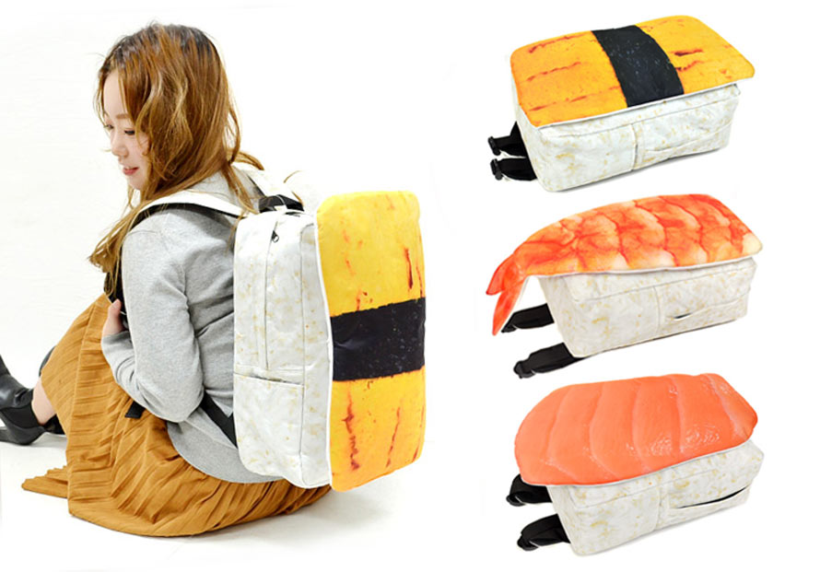**Kids wear your backpacks to church on Sunday 17th so YOU and your pack can be blessed before the new school year starts. We love you and so does your God.**



**Celebrate All the AUGUST Birthdays!!!**

2-Kylar Severson 6-Alec Amonson 6-Melia Asche

8-Easton Amonson 8-Weston Amonson 10-Breckley Sadler

11-Donna Chambers 14-Lincoln Evje 18-Jakayli Traeger

19-Sue Wesselink 22-Barb Forbes 28-Frannie Hansen

*Wish each a Happy Birthday!*

**Everyone Has a Gift---Use It to Help Serve God’s Kingdom**

September is just around the corner of August. Planning is happening now for Sunday School, Kids Club, and Youth Group. These do not happen with the wave of a wand. Volunteers are needed for all kinds of things.

Please ask yourself how you can help keep events going for our children of the church. One program in desperate need is the Kids Club which happens on Wednesday afternoon. This weekly program gives the kids a safe place to go on early outs from school while learning to be disciples of Christ. Kiddos sometimes go home to an empty house with just the TV to entertain. This is the only time some of these kids get to come to church and learn about Jesus. There is about 25-33 kids who come on Wednesdays. It takes leaders, helpers and kitchen workers to create, serve and clean up. Please don’t let this program disappear. Call or sign up by letting the church office know before the end of August.

**Lazy Sundayz at the Rescue Ranch**

**AUGUST 10 4-7 P.M. Family fun**

**Chalk Contest See the animals! See friends and**

**1078 230th St. meet new friends. Mom and Dad**

**Goldfield can have fun, too!**

**The Ice Cream Social**

Many thanks to all the UMC members who contributed to the purchasing of supplies for the Ice Cream Social held July 20th. The free-will event was a success with the help also from the public attendance. Members of the United Methodist Women of Faith are a small but mighty group who appreciate your support.

**A bit of eye rolling and laughing is good for our health!**

+Do trees poop? Sure, where else do #2 pencils come.

+Who do call to clean the ocean? Mermaids.

+Where do rainbows go after being arrested? Prism.

+What's the difference between a piano and a fish? You can tune a piano but you can't tuna fish.

+What do you get when you cross an ornery sheep with a crabby cow? A real baa-d moo-d.