PAugust 24, 2025
PRELUDE/CANDLELIGHT
WELCOME & ANNOUNCEMENTS
*HYMN: Immortal, Invisible, God Only Wise UMH 103
*CALL TO WORSHIP: One: Before you were born, God knew you. Before you spoke, God appointed you.
All: We come, not by our strength, but by God’s calling and grace.
One: The Lord is our refuge, our rock, our confidence since birth.
All: We worship the One who lifts the lowly and heals the broken.
One: Let us worship with reverence and awe, for our God is merciful and mighty.
*OPENING PRAYER (Unison)
Holy and compassionate God, you call to us before we are ready, you speak truth before we feel equipped, and you work healing even when others would rather wait. We gather today because you are faithful. Your mercy is older than our doubts, and your love is wider than our fears. As we enter this time of worship, lift what is bent within us. Free us from shame and silence. Let your Spirit move freely among us—shaping us into people of praise, compassion, and courage. In the name of Christ, our healer and Lord, Amen.
*HYMN: O Master, Let Me Walk With Thee UMH 430
PRAYERS: Joys & Concerns – Silent Prayer – Pastoral Prayer
BLESSING: Please help bless the children’s & backpacks.
OLD TESTAMENT LESSON: Jeremiah 1:4-10 Susan Stein
NEW TESTAMENT LESSON: Hebrews 12:18-29
*GOSPEL LESSON: Luke 13:10-17
*GLORIA PATRI UMH 70
MORNING MESSAGE: Created on Purpose for a Purpose
AFFIRMATION OF FAITH: Apostles’ Creed UMH #881
PRAYER OF CONFESSION
Gracious God, you know how we hide behind habit and tradition. You know the ways we avoid your call—pointing to our limitations, resisting disruption, clinging to comfort. We confess that our worship has sometimes lacked heart, and our faith has sometimes lacked mercy. Forgive us. Unbind what is twisted within us. Stretch our spirits with your grace. May we reflect your justice and healing in the world, trusting not in ourselves, but in you alone. We pray in the name of Jesus Christ, our Redeemer and Friend. Amen.
WORDS OF ASSURANCE
Hear this promise from Hebrews 12:28: “Let us be grateful for receiving a kingdom that cannot be shaken.” In Jesus Christ, we are not condemned—we are welcomed, healed, and made whole.
*OFFERTORY & DOXOLOGY
*PRAYER OF DEDICATION
Unshakable God, we bring these gifts before you, not as mere offerings, but as acts of faith in your unshakable kingdom. Even when the world around us trembles, we trust in your steadfast love, knowing that in Christ, we are welcomed, transformed, and sent forth to serve. Bless these gifts, that they may be used to build your justice and mercy, bringing hope to the broken and light to the weary. With grateful hearts, we offer ourselves alongside these gifts, that we may be signs of your grace in the world. In Jesus’ name, we pray. Amen.

*THE LORD’S PRAYER
*BENEDICTION
Go now in the blessing of God’s love that cannot be shaken, trusting in God’s promises as you work for a world of justice and mercy for all. Amen.
*HYMN: I’m So Glad Jesus Lifted Me TFWS 2151
*Stand as you are able.

UPCOMING INFORMATION
Newsletter information needs to be in by Aug. 25, please.
Aug 25-FIRST DAY OF THE 2025-26 SCHOOL YEAR.
Dial-A-Devotion- Melody Amonson
Aug 27- Administrative meeting 5:30 P.M.
Aug 31- Pulpit-Ann Trimble Ray
Greeters- Dirk and Denise Helmick
Liturgist- Kenlee Link
Coffee- Lavonne Deuel
September 1 is Labor Day.
Congratulations to Azlyn Amonson for her HOLE IN ONE on Thursday, 14th, at the SaddleBack Ridge at Solon, Iowa. Dad cheered and ran around the car pumping his fist.

EAGLE GROVE UNITED METHODIST CHURCH
AUGUST 24, 2025 9:30 A.M. SERVICE
ANN TRIMBLE RAY

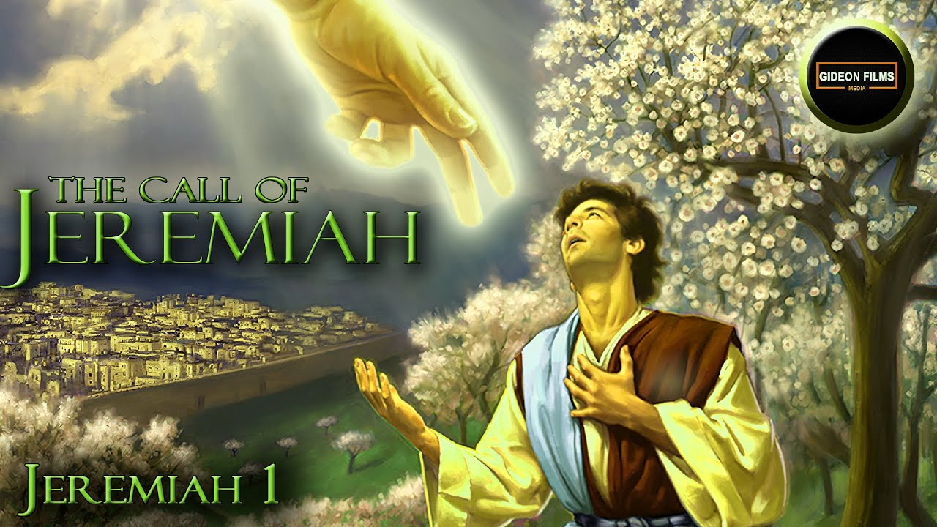
Jeremiah 1: 4-10
“…Before I formed you in the womb I knew you, before you were born I set you apart; I appointed you as a prophet to the nations.”

